**Project Design Phase 1**

**Solution Architecture:**

Solution architecture is a complex process – with many sub-processes – that bridges the gap between business problems and technology solutions. Its goals are to:

* Find the best tech solution to solve existing business problems.
* Describe the structure, characteristics, behavior, and other aspects of the software to project stakeholders.
* Define features, development phases, and solution requirements.
* Provide specifications according to which the solution is defined, managed, and delivered.



Data pre

processing

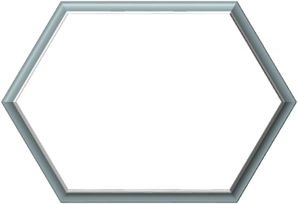

Identify

the factors

for poor

crop yields

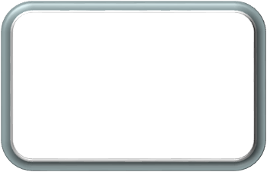

Analysis of

parameter related

to crop

yield



Loading the

dataset



Retrieving the

dataset



the

Analyse

important factors to

increase crop yield



DATABASE

SERVER

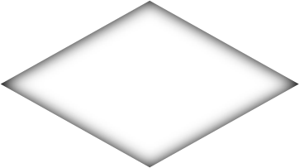

DATA

ANALYST



Crop production

data